Brown, Craige (from Linked In)

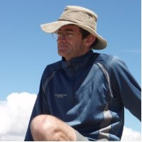

BSc Forestry ANU 1981. AIEM Grad Cert (EM), Emergency Management 2006 – 2007.

Forest Manager Turama Forest Industries/PNG Forest Products 1992 – 1997. Fire Manager Forests NSW 2004 – 2007. Team Leader Melbourne Water 2007 – 2008. Assistant Chief Fire Officer (Operation) DSE 2008 –2010. Secondment. Senior Fire Manager Melbourne Water 2010 –2012. Team Leader Water Supply Catchments & Bushfire Melbourne Water June 2012 – , Docklands.

